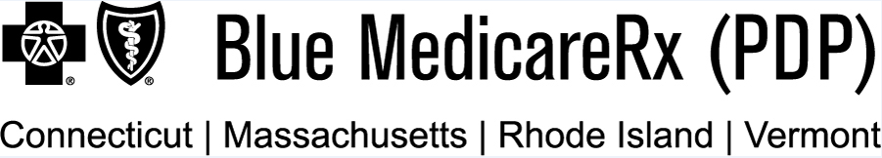

P.O. Box 30012, Pittsburgh, PA 15222-0330

<Date>

<First Name> <MI> <Last Name>
<Address1>
<Address2>
<City>, <ST> <ZIP>

Dear <First Name> <Last Name>:

We reviewed your request to get your coverage back, and your request has been approved. Our records show that we haven’t gotten payment for your plan premium as of <premium due date>. In order for your coverage to be reinstated, we must receive payment in the amount of <enter amount owed> no later than <date 3 months from the effective date of disenrollment>.

[PDP sponsors that include a payment coupon with the letter, insert the following sentences: You can mail your payment to us using the enclosed coupon. Be sure to make full payment of your owed amount and include your member number on the check.]

[PDP sponsors that do not include a payment coupon with the letter, insert the following sentences: You can mail your payment to us at the following address: <billing address>. Be sure to make full payment of your owed amount and include your name and [insert one: member number/billing number/ID number] on the check.]

If we don’t get payment by <date 3 months from the effective date of disenrollment>, you will remain disenrolled from <Blue MedicareRxSM Value Plus (PDP) / Blue MedicareRxSM Premier (PDP)>.

When can I get Part D coverage?
Medicare limits when you can make changes to your coverage. From October 15 through December 7 each year, you can join, switch or drop a Medicare health or drug plan for the following year. Generally, you can’t make changes at other times except in certain situations, such as if you move out of your plan’s service area, want to join a plan in your area with a 5-star rating, or qualify for (or lose) Extra Help paying for prescription drug coverage.

Please remember, if you don’t have other creditable coverage (prescription drug coverage that is expected to pay on average as much as Medicare), you may have to pay a Part D late enrollment penalty if you enroll in Medicare prescription drug coverage in the future.

S2893_1894

Can I get help paying my premiums and other out-of-pocket costs?
People with limited incomes may qualify for Extra Help to pay for their prescription drug costs. If you qualify, Medicare could pay for 75% or more of your drug costs including monthly prescription drug premiums, annual deductibles, and co-insurance. Additionally, those who qualify won’t have a coverage gap or a Part D late enrollment penalty. Many people qualify for these savings and don’t even know it. For more information about this Extra Help, contact your local Social Security office, or call Social Security at <1-800-772-1213>. TTY users should call <1-800-325-0778>. You can also apply for Extra Help online at <www.socialsecurity.gov/prescriptionhelp>.

For questions about making changes to the way you get Medicare, call <1-800-MEDICARE (1-800-633-4227)>. TTY users should call <1-877-486-2048>.

For more information:
If you have any questions regarding the plan premium amount you owe and how you can pay, please call <Blue MedicareRx Value Plus / Blue MedicareRx Premier> at <MS_PHONE>, <24 hours a day, 7 days a week>. TTY/TDD users should call <711>.

Thank you.

Blue MedicareRx (PDP) is a Prescription Drug Plan with a Medicare Contract. Blue MedicareRx Value Plus (PDP) and Blue MedicareRx Premier (PDP) are two Medicare Prescription Drug Plans available to service residents of Connecticut, Massachusetts, Rhode Island, and Vermont.

Coverage is available to residents of the service area or members of an employer or union group and separately issued by one of the following plans: Anthem Blue Cross® and Blue Shield® of Connecticut, Blue Cross Blue Shield of Massachusetts, Blue Cross and Blue Shield of Rhode Island, and Blue Cross and Blue Shield of Vermont.
Anthem Insurance Companies, Inc., Blue Cross and Blue Shield of Massachusetts, Inc., Blue Cross & Blue Shield of Rhode Island, and Blue Cross and Blue Shield of Vermont are the legal entities which have contracted as a joint enterprise with the Centers for Medicare & Medicaid Services (CMS) and are the risk-bearing entities for Blue MedicareRx (PDP) plans. The joint enterprise is a Medicare-approved Part D Sponsor. Enrollment in Blue MedicareRx (PDP) depends on contract renewal.

Independent Licensees of the Blue Cross and Blue Shield Association ®Registered Marks of the Blue Cross and Blue Shield Association. ®´, SM, TM Registered Marks and Trademarks are property of their respective owners. ©2022 All Rights Reserved.

